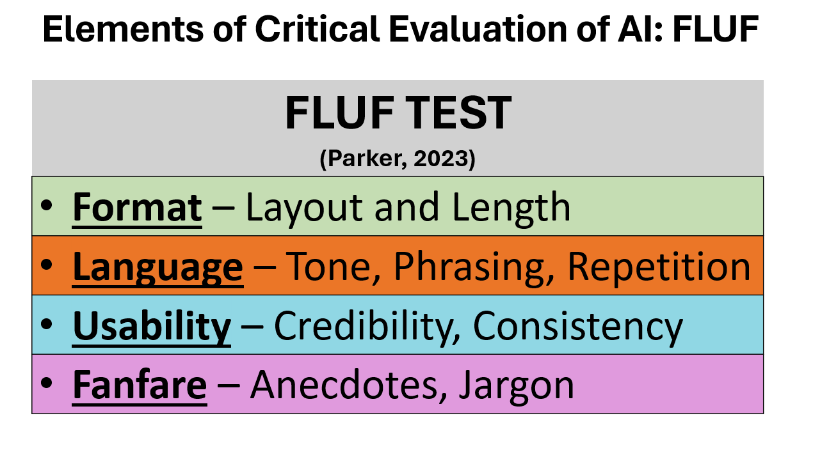

Critical Evaluation of AI Generated Content: The FLUF Test
Created by Dr. Jennifer Parker
University of Florida
Center for Teaching Excellence

Underpinnings For This Work
Respect the 80/20 Rule of the Process
The 80/20 Rule (Pareto Principle)
The balance between human insight and technological capability
- 80% research and regeneration of online sources
- 20% human critique, creativity, and culmination to create a final output
Critically Evaluate All Online Content
Frameworks for Critical Evaluation of Online Resources
- CRAAP (Blakeslee, 2004) – currency, relevance, authority, accuracy, purpose
- CARRDSS (Valenza, 2004) – credibility, accuracy, reliability, relevance, date, sources, scope
- SIFT (Caulfield, 2019) – stop, investigate, find, trace
- 5 Key Questions (Thorman & Jolls, 2003) – creator, techniques, perceptions, bias, purpose
Critically Evaluate All AI Generated Content
How to Use the FLUF Test (Parker, 2023)
- Review FLUF indicators – format, language, usability, fanfare
- Create a prompt using FLUF guidance
- Generate results and FLUF test
- Update prompt; regenerate; FLUF test
- Repeat until happy with results and zero FLUF
- Combine AI Results & Human Creativity and Critique to Generate a Final Product
  - Step 1: Review the FLUF indicators.
The FLUF test was designed as a framework to critically evaluate content generated by artificial intelligence. Using the Format, Language, Usability, and Fanfare approach, participants examine the AI results for evidence of infractions. Format infractions include layout or length issues. Language infractions hit on tone, phrasing, or repetition of information. Usability infractions involve consistency or credibility. Finally, Fanfare infractions miss the mark on anecdotes and/or jargon. The goal is to regenerate and rewrite content down to zero FLUF with zero infractions.
Indicator | List Infractions | GOAL: ZERO FLUF
 |  | Plus = yes, there are infractions/fail | Minus = no infractions/pass
FORMAT
Layout |  | +/-
Length |  | +/-
LANGUAGE
Tone |  | +/-
Phrasing |  | +/-
Repetition |  | +/-
USABILITY
Consistency |  | +/-
Credibility |  | +/-
FANFARE
Anecdotes |  | +/-
Jargon |  | +/-
Add up the “+” to see the issues with the AI generated content. |  | ____/____
Another view of the FLUF Test is below:
FORMAT |  | LANGUAGE |  |  | USABILITY |  | FANFARE |  | FLUF SCORE  (GOAL: ZERO FLUF)
Layout  (+/-) | Length  (+/-) | Tone  (+/-) | Phrasing  (+/-) | Repetition  (+/-) | Credibility  (+/-) | Consistency  (+/-) | Anecdotes  (+/-) | Jargon  (+/-) | +Plus = yes, there are infractions or errors present | -Minus = no, there are no infractions present
 |  |  |  |  |  |  |  |  | SCORE:
FLUF Test for Artificial Intelligence Generated Content by Dr. Jennifer Parker, University of Florida – Center for Teaching Excellence and is licensed by a Creative Commons Share/Share Alike 4.0 license.

  - Step 2: Create a Prompt.
Prompt Element | Prompt information

Who

What

Where

When

Why

How

Format

Layout

Usability

Fanfare
From the information above, generate the prompt

  - Sample of FLUF the Prompt Process
  - 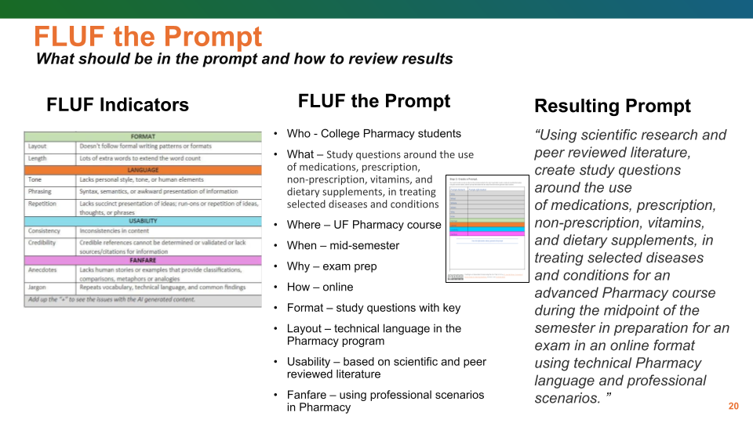

  - Step 3: Generate Results and Apply FLUF Test to Samples.

INITIAL RESULTS - FIRST ITERATION
Copy/Paste Prompt

Copy/Paste AI Generated Results

Apply the FLUF Test
FORMAT |  | LANGUAGE |  |  | USABILITY |  | FANFARE |  | FLUF SCORE  (GOAL: ZERO FLUF)
Layout  (+/-)  - | Length  (+/-)  + | Tone  (+/-)  - | Phrasing  (+/-)  - | Repetition  (+/-)  - | Credibility  (+/-)  - | Consistency  (+/-)  - | Anecdotes  (+/-)  - | Jargon  (+/-)  - | +Plus = yes, there are infractions or errors present | -Minus = no, there are no infractions present
 |  |  |  |  |  |  |  |  | SCORE: 1

Share/discuss the score and results of the regenerated results.

- Format –
- Language –
- Usability
- Fanfare –
- Score =

Recommend

  - Step 4: Update the prompt; regenerate; FLUF Test
REGENERATED RESULTS - SECOND ITERATION
Copy/Paste Prompt Revisions or Additions

Copy/Paste AI Generated Results

Apply the FLUF Test on the regenerated results
FORMAT |  | LANGUAGE |  |  | USABILITY |  | FANFARE |  | FLUF SCORE  (GOAL: ZERO FLUF)
Layout  (+/-)  - | Length  (+/-)  + | Tone  (+/-)  - | Phrasing  (+/-)  - | Repetition  (+/-)  - | Credibility  (+/-)  - | Consistency  (+/-)  - | Anecdotes  (+/-)  - | Jargon  (+/-)  - | +Plus = yes, there are infractions or errors present | -Minus = no, there are no infractions present
 |  |  |  |  |  |  |  |  | SCORE: 1

Share/discuss the score and results of the regenerated results.

- Format –
- Language –
- Usability –
- Fanfare –
- Score =

Recommend

  - Step 5: Repeat until happy with results and zero FLUF.
Regenerated Results/Ongoing Iterations

Copy/Paste Prompt Revisions or Additions

Copy/Paste AI Generated Results

Apply the FLUF Test
FORMAT |  | LANGUAGE |  |  | USABILITY |  | FANFARE |  | FLUF SCORE  (GOAL: ZERO FLUF)
Layout  (+/-)  - | Length  (+/-)  + | Tone  (+/-)  - | Phrasing  (+/-)  - | Repetition  (+/-)  - | Credibility  (+/-)  - | Consistency  (+/-)  - | Anecdotes  (+/-)  - | Jargon  (+/-)  - | +Plus = yes, there are infractions or errors present | -Minus = no, there are no infractions present
 |  |  |  |  |  |  |  |  | SCORE: 1

Share/discuss the score and results of the regenerated results.

- Format –
- Language –
- Usability
- Fanfare –
- Score =

Recommend

Step 6: Combine AI results with human creativity critique for a final product.
AI + HUMAN - ITERATION

Use your Superhuman capabilities and rewrite the last-best results to an acceptable submission that has zero FLUF. Share the results of your AI generated plus human results.

Share the link or final results of your 80/20 combination.

